SMARANDA BRĂESCU - the first parachutist woman with a patent from Romania
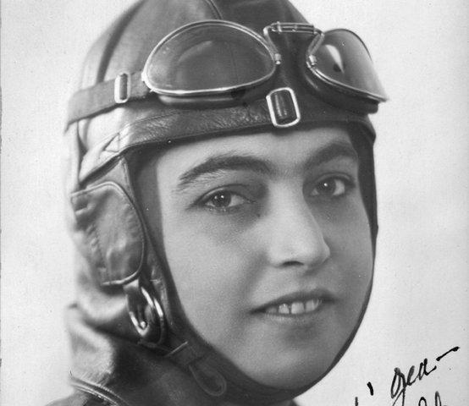
Called "The Queen of the Heights," Smaranda Brăescu, born in 1897, in Galati County, was the first parachutist woman with a patent in Romania.
When she was 26, she flew for the first time on an aerodrome. After this fascinating experience, the youngster began to want to go even further. But in those times, this occupation was forbidden to women. She did not get discouraged and went to Berlin, where she went on parachuting courses "Heineke" to the famous Schroder & Co home, from where she obtained the international paratrooper patent. She was 30 years old and worked hard for her passion. It was supported and encouraged by engineer Heinecke, with whose help she bought a parachute. The ambition of the Romanian woman has improved her every jump. In 1931, Smaranda Brăescu received from the Romanian Military Aviation Command the approval to try to beat the women's records from the United States and Europe.
On October the 2nd, 1931, she won the European skydiving title, following a leap from a height of 6000 meters, surpassing the previous record of 5384 meters, thus obtaining the world record for women.
After intense training, Smaranda Brăescu managed to break down the record held by an American. Thus, on May 19, 1932, in Sacremento, California, the Romanian jumped from an altitude of 7,400 meters. It was a dangerous jump, one of the parachutes opening very late. The landing was a success, however, and the overseas press was fascinated by the courageous Romanian.
Smaranda Brăescu took full advantage of her stay in the United States of America and enrolled in flight training courses. Following a flight to Roosevelt Aviation Field, she obtained the much-desired patent.
Returned to Romania, Smaranda was decorated by King Carol II with the second bar at the "Golden Cross of the Virtue of the Aeronautic Order", the King being the Honorary President of the Royal Aeroclub.
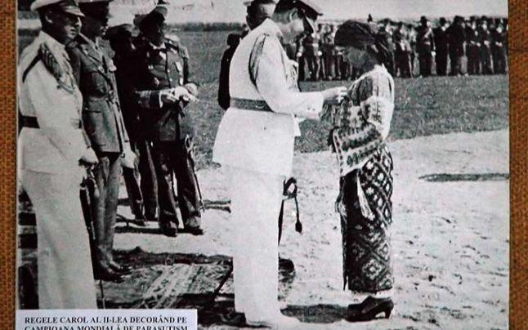 The decoration of Smaranda Brăescu by King Carol II
In 1935, Smaranda managed to buy a light and inexpensive plane, which she sent to Reading, near London, for checks. On her way home, Smaranda crossed the Channel through the fog. Later, she stopped with the “Aurel Vlaicu” plane (as she had called it) in Paris, Nancy - Strasbourg, Landsberg, Munich, Vienna.
In her flight, Smaranda Brăescu wore the Romanian flag in the sky of Europe, the aircraft having the blue fuselage, and the wings were painted in the "Romanian tricolor": blue, yellow and red.
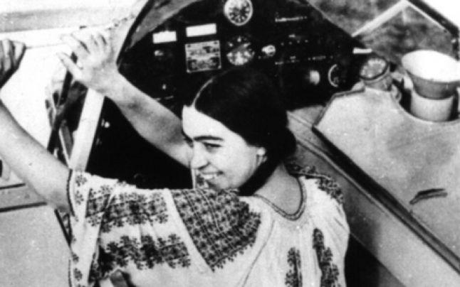 Smaranda Brăescu, in a Romanian folk costume
A true patriot, Smaranda Brăescu participated alongside aviators and paratroopers in the battles of the Second World War. In 1941 she worked as a volunteer instructor in the 1st Parachute Battalion. She also worked as a volunteer in the Sanitary " White Squadron " on the eastern front, and on the west front in 13 Squadron for Recognition, Observation and Connection, and then in Liaison Squadron no. 113 until the end of the war.
For her entire work on the front, Smaranda Brăescu was decorated and received the "Queen Maria" Cross, a very important Romanian distinction at that time.

